**Unlocking the power of data with Tableau Calculations**

**Tableau Calculations: The secret to data driven success**

What are Data Insights?

Data insights are the meaningful and valuable information gleaned from analyzing data, which empower decision-making, pattern recognition, and a deeper grasp of a particular subject or scenario.

Failing to effectively utilize and scrutinize organizational data undermines its capacity to fuel expansion and enhance operational effectiveness within the company.

Key Takeaways

* Comprehend Tableau calculations and the various types they encompass.
* Suggestions for mastering the creation of calculations and selecting the optimal calculation type.
* Acquire expertise in employing the best practices for crafting calculations within Tableau.

Why use tableau calculations?

Tableau calculations play a crucial role for various purposes:

* Custom Analysis: They enable users to conduct tailored analyses, offering deeper insights into the data.
* Advanced Metrics: Calculations facilitate the creation of sophisticated metrics and key performance indicators (KPIs) that go beyond the basic dataset.
* Data Transformation: By applying mathematical operations, logical functions, and conditional statements, calculations transform raw data into meaningful insights.
* Visualization Enhancement: Calculations enrich visualizations by providing context, highlighting trends, and adding additional layers of information.
* Decision Making: They support decision-making processes by offering additional context and insights, assisting in making informed choices based on data.
* Forecasting and Prediction: Utilizing historical data and statistical functions, calculations enable forecasting and prediction of future trends and outcomes.

Getting Started with Tableau Calculations

Calculated Fields:

Calculated fields in Tableau refer to custom fields that are created by users using formulas or expressions to perform specific calculations on data. These calculations can involve mathematical operations, logical comparisons, string manipulations, and more.

Calculated fields enable users to discover new insights from their data, create customized metrics, and enhance visualizations with additional contextual information.

They are a powerful feature in Tableau that enables users to perform complex analysis and tailor their visualizations to meet their specific analytical needs.

Types of Calculations

There are three main types of calculations you can use to create calculated fields in Tableau:

* Basic calculations
* Level of Detail (LOD) expressions - Just like basic calculations, LOD calculations allow you to compute values at the data source level and the visualization level. However, LOD calculations give you even more control on the level of granularity you want to compute. They can be performed at a more granular level (INCLUDE), a less granular level (EXCLUDE), or an entirely independent level (FIXED) with respect to the granularity of the visualization.
* Table calculations - Table calculations allow you to transform values at the level of detail of the visualization only.

The type of calculation you choose depends on the needs of your analysis and the question you want to answer.

*Note: The example in this article uses the Sample-Superstore data source that comes with Tableau Desktop. To follow along with the steps in this article, connect to the Sample-Superstore saved data source and navigate to Sheet 1.*

Basic Calculations

Basic calculations enable the transformation of values or members either at the data source level of detail (a row-level calculation) or at the visualization level of detail (an aggregate calculation).

Row - level calculation:

In row level calculation, calculation is performed for every row in the data source. It is also called data source level calculation.

For example, consider creating a column to find the Time taken in days to ship an order.

1. In Tableau, select Analysis > Create Calculated Field.
2. In the Calculation Editor that opens, do the following:
   * Enter a name for the calculated field. In this example, the field is called Shipping Time.
   * Enter a formula. This example uses the following formula:

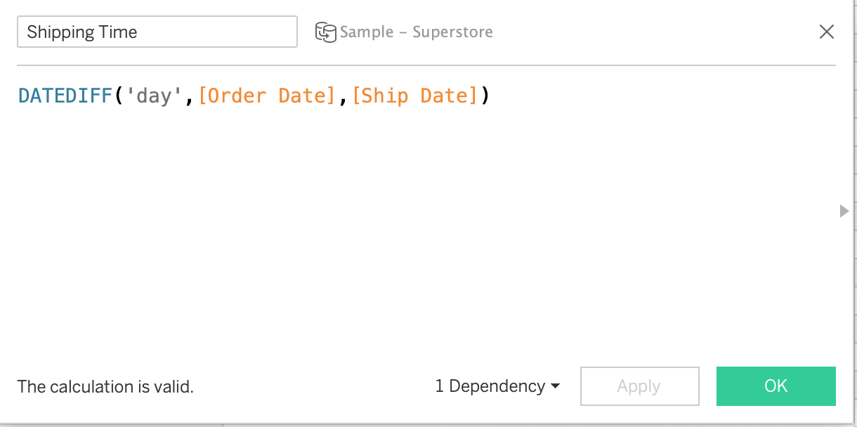

1. Drag and drop OrderId, Order Date, Ship Date to Rows shelf. For Order Date and Ship Date pills, select the second date and change to Discrete from continuous.
2. Drag and drop Shipping Time to Rows. Change it to Dimension and then to Discrete.

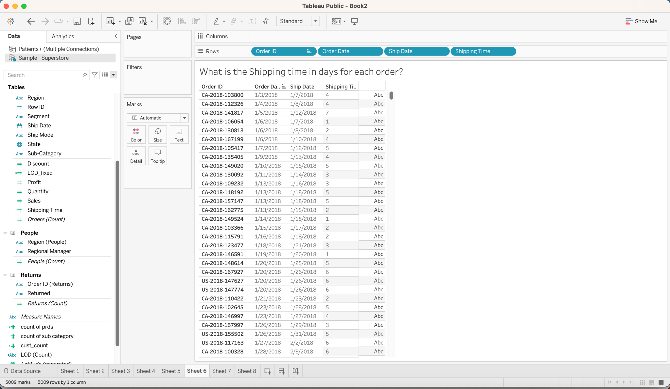

Aggregate Calculation

In aggregate or visualization-level calculation, computations are performed based on the detail level of the visualization.

For example, consider showing the count of sub-categories for each category.

1. Create a calculated field as shown below.
2. Drag and drop Category to Rows. And drag the calculated field ‘count of sub category’ to rows. Change it to Discrete from continuous.

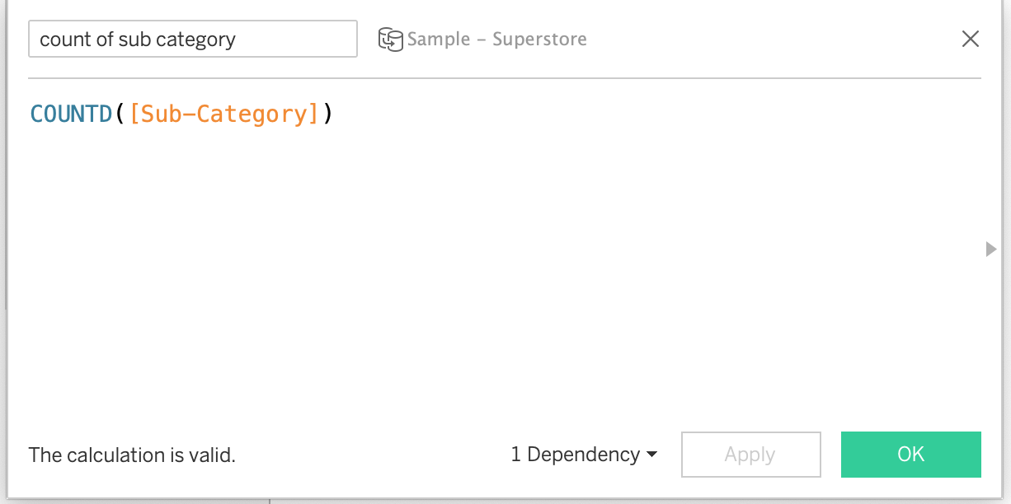

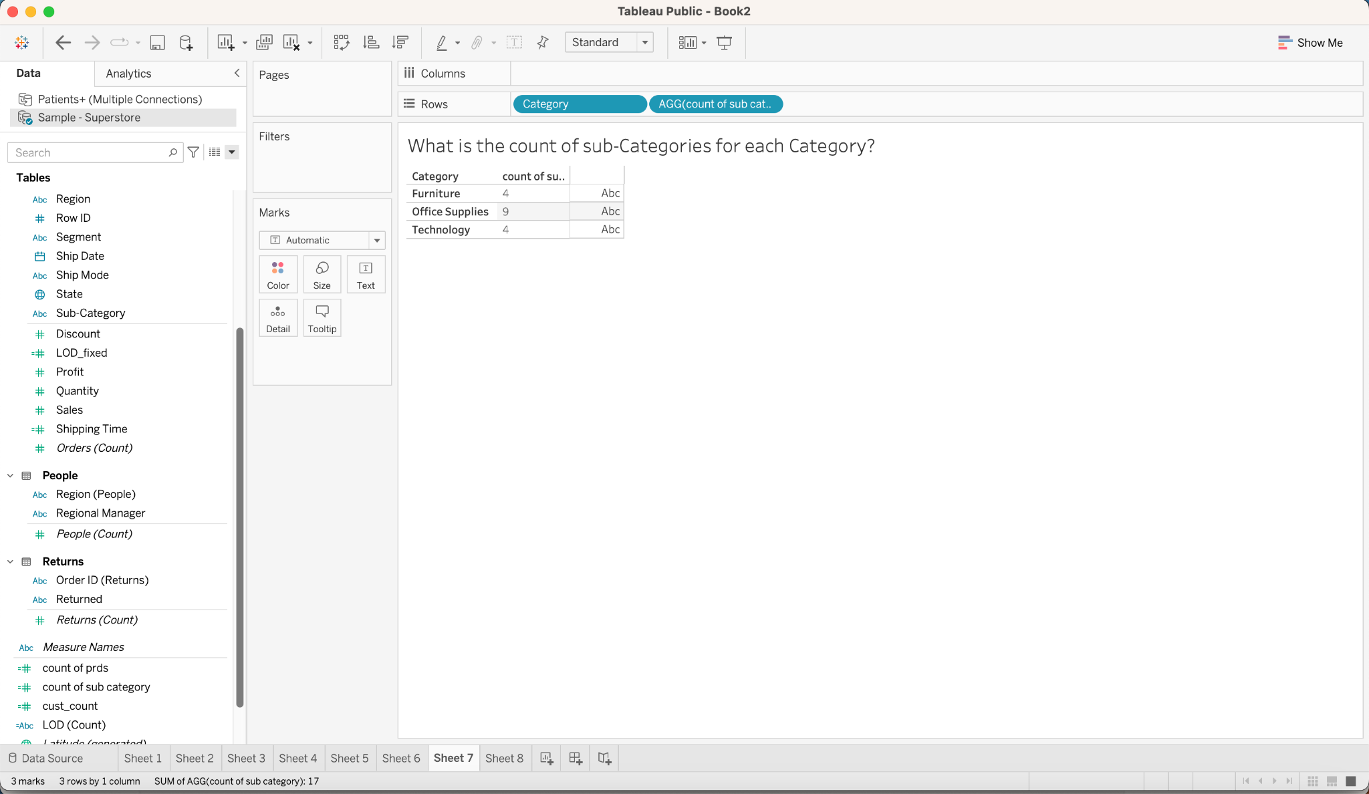

Level of Detail(LOD) Expression

LOD expressions enable computation of values at both the data source and visualization levels. It allows the aggregation of data at specified dimension level.

Moreover, they offer greater control over the granularity of computation.They can be executed at

* a more detailed level (INCLUDE),
* a less detailed level (EXCLUDE),
* a completely independent level (FIXED).

LOD expression syntax

A level of detail expression has the following structure:

{ [FIXED | INCLUDE | EXCLUDE] <dimension declaration> : <aggregate expression>}

{ }

The entire level of detail expression is enclosed in curly braces.

INCLUDE LOD expression